D19: WP TEST – BUGS applied on the Ruhr area - MICRO
Annette Thierry og Jette Esbjørn Hess - DTPI
1st draft 27. januar 2004

2.5 Participatory planning

From the outset of the BUGS project, there has been a particular focus on ensuring that the scientific results are of relevance to potential end users such as municipal and regional authorities. Furthermore, it has been a requirement that the results produced should be presented to and discussed with local citizens in the Ruhr district.

As the BUGS project is a simulated planning process, we assumed that it was not realistic to expect individual citizens to take part in a dialogue about the BUGS scenarios and environmental results. Rather, we expected that local stakeholders with different professional interests (citizen groups, environmental organisations, cooperative housing societies, business representatives etc.) in the selected case areas would find it interesting to participate in a dialogue about the BUGS results and sustainable urban development.

There are many methods, which can be used to initiate a participatory planning process. We have chosen the scenario workshop as our main method of communication for several reasons:

- We wanted to see if a complex subject like sustainable urban development could be communicated to and understood by non-experts. The scenario workshop allowed us to create a setting in time and space, in which we were able to test people’s ability to understand and reflect upon the BUGS method and principles.
- We wanted to create a dialogue forum, which invited the participants to open up for their individual visions about sustainable urban development and at the same time develop common visions.
- A scenario workshop involves three important phases (criticism, vision, realisation), of which the first two (criticism and visioning) could give important feedback to the BUGS scenarios and environmental modelling. We were interested to see how people reacted to the BUGS scenarios and if/how the scenarios could inspire the participants’ own vision making.
- A scenario workshop is employable despite the simulated character of the BUGS project. In fact, a scenario workshop requires scenarios – and not real plans – which made it an obvious choice of method for the BUGS project.
- A scenario workshop is delimited to a short intensive time span, which suits a time and result oriented project like BUGS.

(number???) Scenario workshop
The integrated BUGS scenario workshop was set to take place the 27th November 2003 in Essen. The goal of the workshop was to find answers to the following questions:

- What are the prevalent visions of local stakeholders with respect to sustainable urban development?
- How do local stakeholders appreciate the BUGS concept?
- How can a public debate on sustainable urban development be started and/or improved?

DTPI, KVR and Benjamin Davy, professor for land policy and land management at Dortmund School of Spatial Planning, who had been hired as workshop moderator, did the planning and organisation of the workshop in co-operation. Professor Davy had previously collaborated with eight Ruhr cities in the project Ruhr 2030 as moderator and was very qualified to initiate the BUGS dialogue.

17 stakeholders from the city of Mulheim representing different fields of interest (environment, housing, economy, social affairs, planning) and 3 BUGS representatives participated in the workshop. All in all 20 participants.

The scenario workshop consisted of several elements:

- Card game opening
- Presentation of 10 BUGS principles and the BUGS scenarios
- Group discussion of BUGS scenarios
- Group discussion on using the BUGS scenarios/method in a public debate on sustainable urban development
- Presentation of group results and final discussion

Ad 1) Card game
A card game had been developed and designed by DTPI to stimulate a discussion on different types of housing and their consequences for urban planning. The idea was to see if the surroundings (public or private green, access or view to water, traffic conditions, layout of streets) and not the housing type itself could make people change their mind about their housing preferences. The card game was meant as a “kick starter” (to start people discussing) and as a consciousness-raising exercise.

The participants reacted to the card game unanimously: They clearly rejected living next to major roads, which was considered a disturbance in terms of noise, health, safety and view. Aesthetically, they rejected housing types associated with “modern” urban density (too much glass and steel as building materials, stock houses despite their large common green areas). Many participants preferred historic inner city housing types with green common gardens in relatively quiet neighbourhoods. Detached single-family houses and row houses evoked mixed appraisal; some thought they were too “fenced off”, some that they allowed a nice sense of privacy.

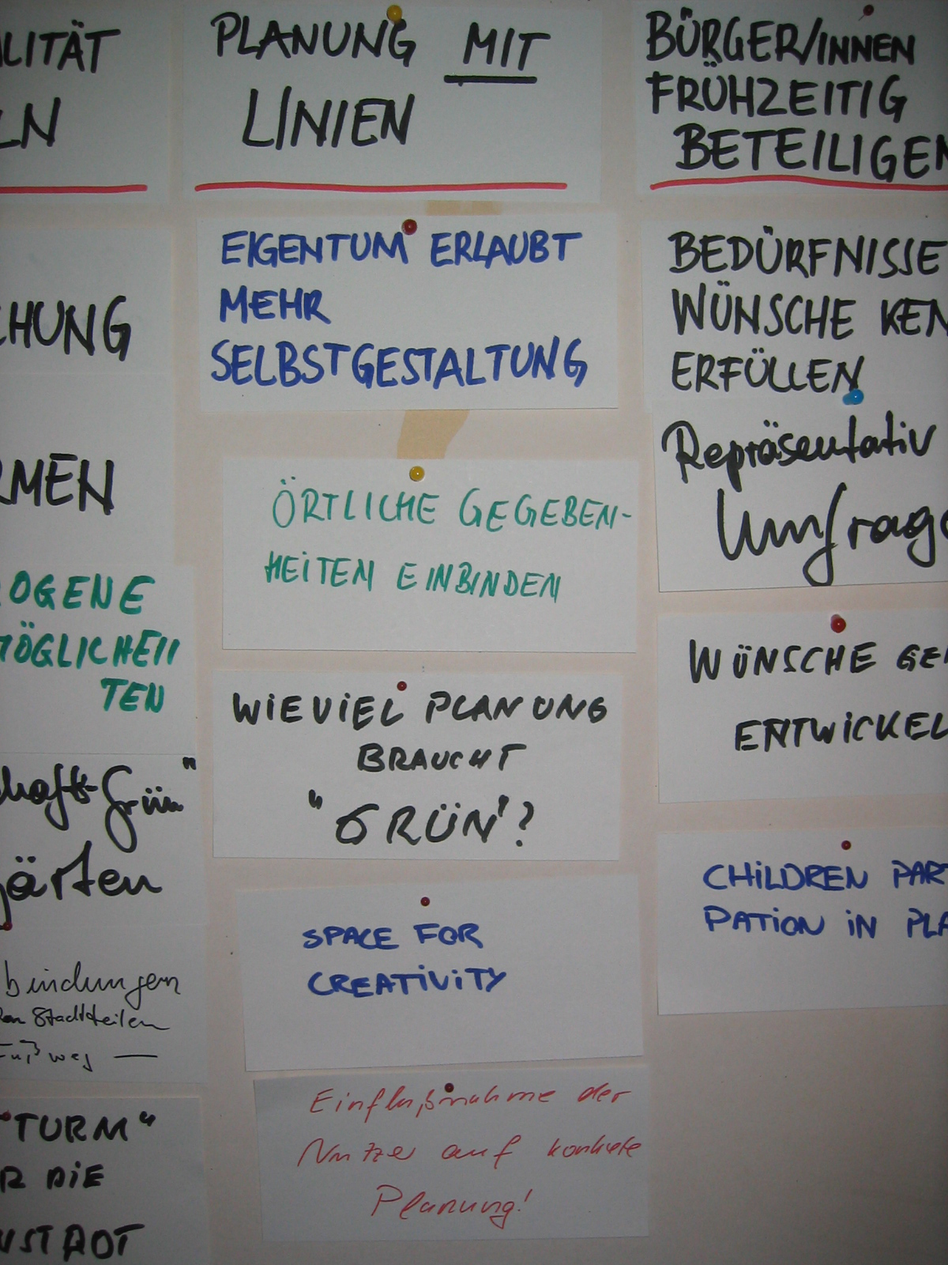
Photo 1: Presentation of group results

Ad 2-5) BUGS principles and scenarios
While preparing for the scenario workshop, the moderator had asked DTPI to formulate 10 BUGS principles, which should be concise statements of what BUGS really stands for. The presentation of the BUGS principles had a specific purpose: To show the participants how the card game relates to the larger task of discussing the BUGS scenarios. Ideally, a person who had been introduced to the BUGS principles should look back upon the card game exercise and realise that his/her personal housing and urban green preferences have an impact on the way a city can develop.

In order to keep people actively involved in the workshop, four participants had been asked to present a BUGS scenario each - instead of the moderator presenting to a passive audience. It turned out to be a good idea: The people presenting the scenarios had clearly read and understood the BUGS compendium, which they had been sent a week before the workshop. However, most of them focused more on the scenario maps rather than on the accompanying photos of housing types (examples of how the proposed housing types could look) or the environmental consequences of the scenarios.

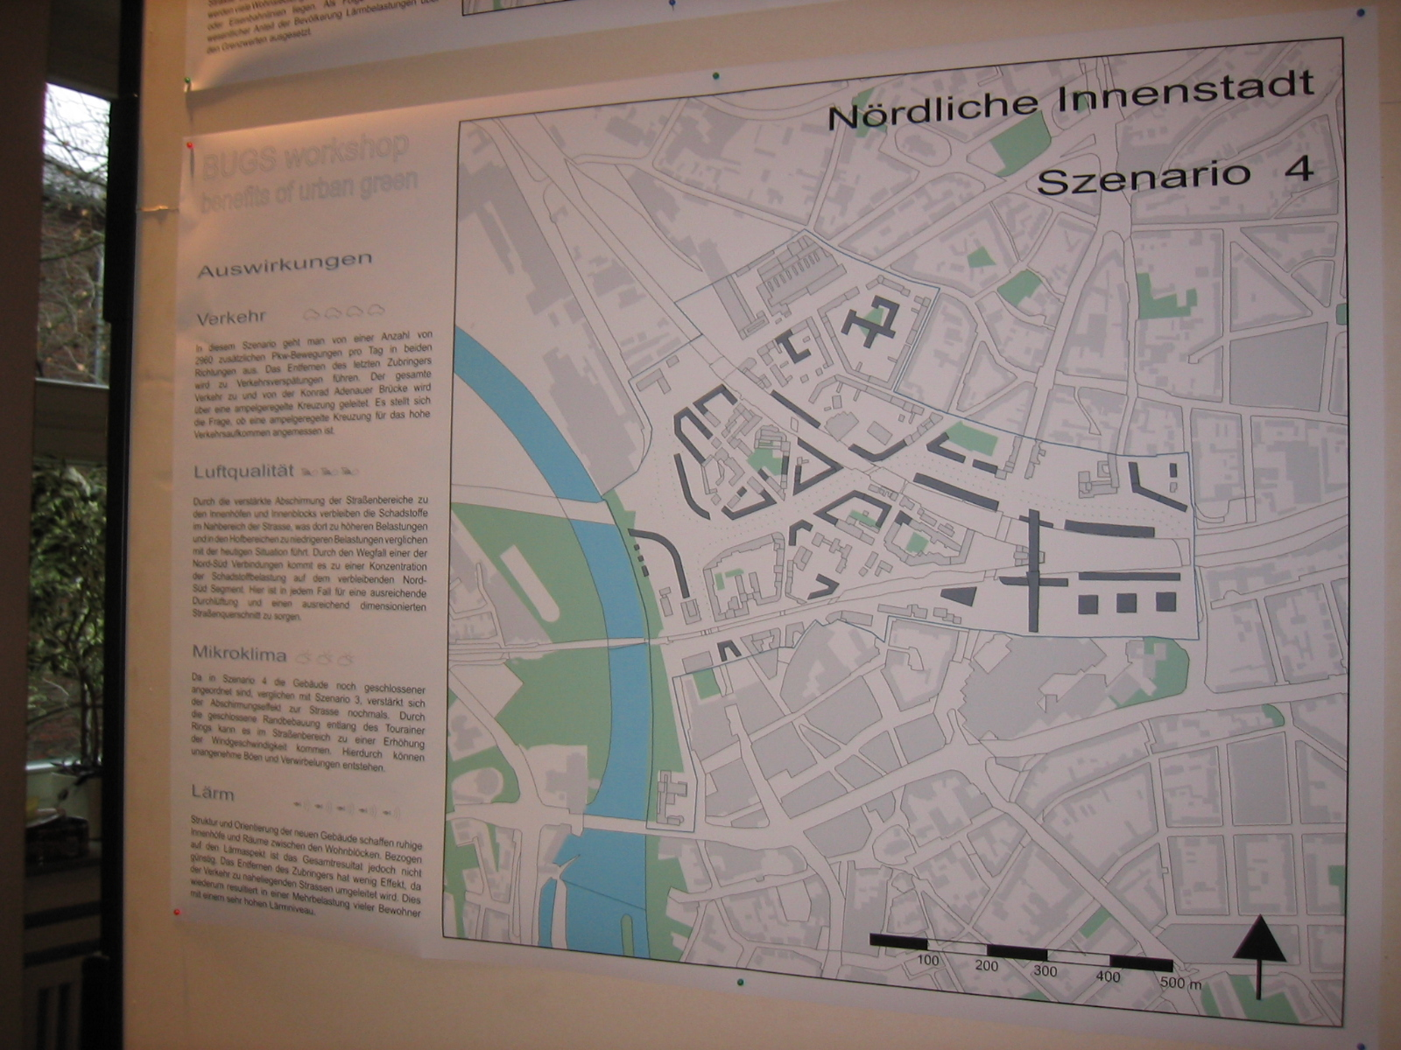
Photo 2: Scenario 2 Nördliche Innenstadt

The fact that the people presenting the scenarios mainly focused on the GIS-maps indicates that the instructions, which people are given beforehand (what to focus on, which issues to address) are extremely important as they guide people in one direction or the other. If the participants presenting the BUGS scenarios had been asked specifically to focus more on the environmental consequences of the scenarios than the GIS-maps, the discussion would probably have been very different. However, as the participants were asked openly to tell how what they “saw” in the scenarios, we didn’t steer them as firmly towards the environmental modelling as we could have done. This could and should be changed if the BUGS methodology was applied again on another city.

The compendium was a good instrument to stimulate discussion but it was rather difficult for the participants to abstract from the GIS-made scenario maps to the visions lying behind the BUGS scenarios. For example, some participants commented on the layout of the housing in the scenarios as being “not organic enough”, despite the fact that we had tried to provide photo examples, which should give people an impression of how the housing could look like. Others asked for a more detailed description of what was going “to happen” in the FWH case area in terms of recreational opportunities, the interplay between residents, institutions and businesses – despite that fact that the BUGS scenarios were not designed as concrete plans for the case areas but as input to a larger debate about sustainable urban development.

An interesting conclusion from the workshop was that the results from the environmental modelling, presented next to the scenarios in the compendium and on big posters in the workshop room, did not have as big an impact on the participants’ discussions and visions about sustainable urban development as expected. People tended to look at the scenario maps rather than on the environmental results. This does not mean that environmental modelling cannot be applied when discussing urban development with a non-professional audience – rather that one has to be very aware of how the environmental results are presented and used in a dialogue process.

In the BUGS material designed for the scenario workshop, we had chosen to present the environmental modelling of the scenarios with icons rating the traffic, micro climate, air quality and noise situation (from 1 to 6, the more icons – the more traffic/worse micro climate etc.) and 4-5 lines about each subject. Maybe this kind of presentation was too simple to describe complex issues such as the impact of for example traffic and noise on people’s everyday life? Maybe we should have chosen to run the professional 3D models of the noise impact or the micro climate modelling? However, we chose not to do so partly because it would take too much of the workshop time and partly because we preferred an active approach where people did not listen to a lot of presentations but got involved in interpretation and discussion from the beginning of the workshop.

Another reason why the environmental modelling did not cause as much debate as hoped for could be due to the nature of the scenarios: After all, the scenarios were not that different but variations over housing types and compactness. As we were not operating with extremes, the environmental modelling didn’t show major differences or thought-provoking results. Furthermore, the modelling partners had not carried through all their modelling when they were asked to contribute with icon ratings and writing to the BUGS compendium. This may have resulted in rather general evaluations of the environmental consequences – evaluations that were not able to “kick off” discussion at the workshop.

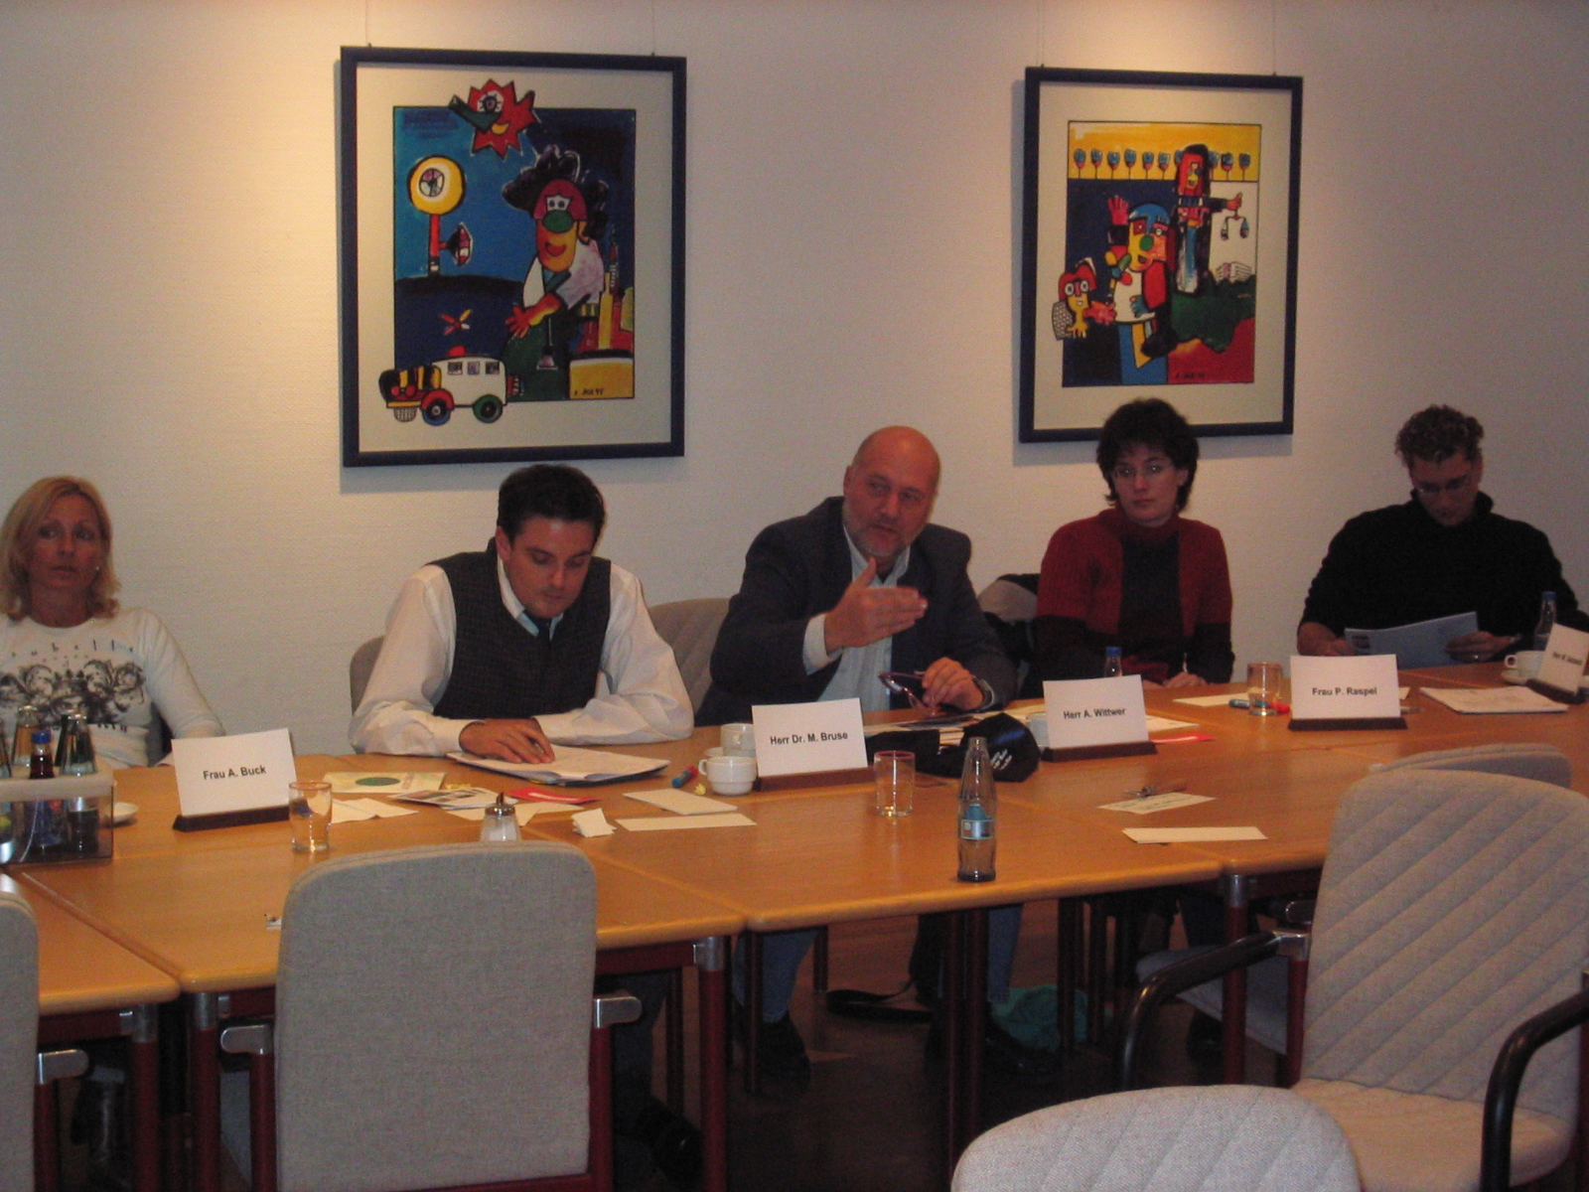
Photo 3: Discussion on the BUGS-project

An important participant critique of the BUGS project was that it does not deal enough with the socio-economic consequences of urban development (the market). Which types of housing attract which people? Is the housing in the scenarios affordable? If not, only well-off people can move into the area, making it a segregated area. One participant called the FWH scenario 1 for “elitist” housing as the relatively low density would mean high housing prices. The same person designated the FWH scenario 2 “ghetto housing” as he figured that well-off people wouldn’t move into an area where they a) were only allowed to park their car in a parking house on the outskirts of the area and b) were going to live rather close to their neighbours.

In conclusion, the experiences from the workshop discussion showed that – in a project about urban development – it is important to deal in dept with the question: How does different types of ownership (rental, co-op, owner) affect the social and economic dynamics of the city? In other words, it is not enough to address mainly the environmental consequences of urban development as the BUGS project does. One has to see it in a broader perspective and realize that a debate on sustainable urban development cannot be isolated from the workings of the market or the issue of social segregation and identification. Environmental, economic and social factors are indistinguishable in people’s everyday perspective and should be treated as such when trying to create a public debate about sustainable urban development.

Many people are only willing to spend time and energy on issues, which concern their everyday life.
See the BUGS report ”Guidelines to participatory planning – a simulated planning process in the Ruhr” (2002).
These principles should be mentioned in the introduction to the report, in an appendix or somewhere else…

